**Digital System Design**

**BS(CE)-2k20**

**Semester Project Report**

**Traffic Control System**



**Submitted By:**

Abdullah Javed 20-CE-035

Ayesha Ehtisham 20-CE-038

**Submitted To:**

Engr. Fasih Ahmed

**Department of Computer Engineering**

**HITEC University Taxila**

Contents

Introduction: 4

Problem Scenario: 4

Objective: 4

Requirements: 5

Tools Used: 5

Major Design & Function Areas: 5

Block Diagram: 6

Truth Table: 6

State Transition Table: 7

Verilog Code: 8

Flowchart: 13

State Diagram: 14

Conclusion: 14

**List of Figures**

Figure 1 Lanes and Signals 4

Figure 2 Block Diagram 6

Figure 3 Verilog Code 8

Figure 4 Flowchart 13

Figure 5 State Diagram 14

**List of Tables**

Truth Table ………………………………………………………………………………………………………………………… 6

State Transition Table ……………………………………………………………………………………………………….. 7

**Traffic Control System in Verilog HDL**

# Introduction:

Our project scenario is that we have to develop a digital system which controls the flow of traffic on an intersection. This intersection has 4 lanes and each lane has a separate traffic signal. We need to develop a synchronous control system which controls all the signals.

# Problem Scenario:

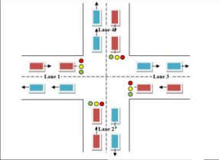

Figure 1 Lanes and Signals

# Objective:

The task is to design a state machine for a traffic control system for a 4 way road interchange, the state machine should follow the mentioned aspects of the system

1. Transitions must be in sequence, i.e. L1 -> L2 -> L3 -> L4

2. Resetting the system will bring the state machine to its *rst state,* where all the roads will be blocked until reset is released

3. Each Lane must get its **movement time** (*green lights on*)

4. Between each transition, there must be **clearance time** i.e. *red light* must be on for a short amount of time of both lanes

**5.** Lane 1 and Lane 3 are busy roads (main roads) so they should get larger **movements time** 6. Delay time for each light is given in the following table

# Requirements:

The following table describes the required time for each of the lanes for movement, stoppage and clearance:

|  |  |  |  |  |
| --- | --- | --- | --- | --- |
| Lane | Movement time (clock cycles) | Stop Time  (clock cycles) | Yellow Time (clock cycles) | Clearance Time (clock cycles) |
| L1 & L3 | 30 | 30 | 5 | 5 |
| L2 & L4 | 20 | 30 | 5 | 5 |

# Tools Used:

* EDA Playground
* Icarus Verilog Compiler
* GTK Wave
* Verilog HDL
* Lucid chart (For Flowchart and State Diagram)

# Major Design & Function Areas:

* Each State is given separate output
* Use of parameters
* Main logic is created with the help of case statement
* Assign method used for output
* External clock used for synchronous operation

# Block Diagram:

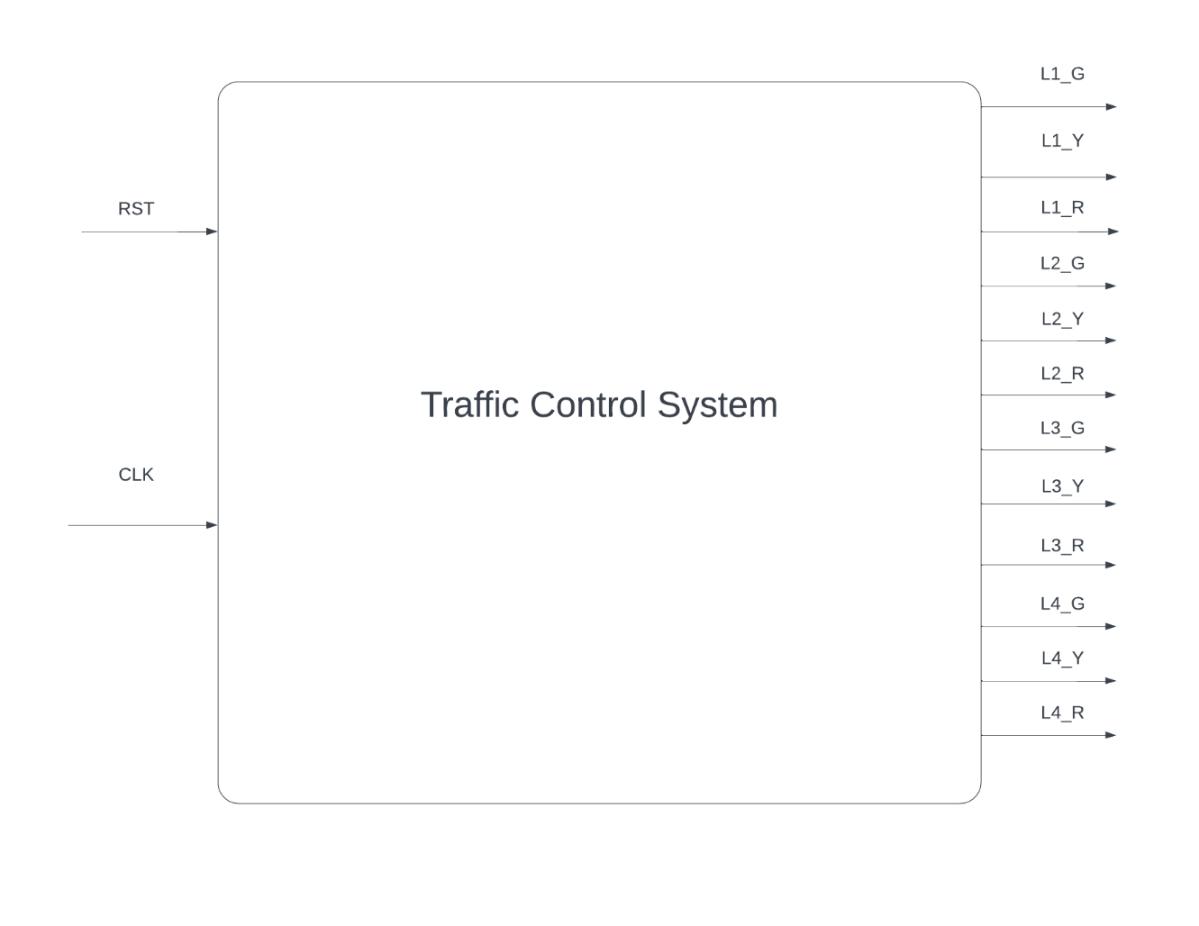

Figure 2 Block Diagram

# Truth Table:

|  |  |  |  |  |  |  |  |  |  |  |  |  |  |
| --- | --- | --- | --- | --- | --- | --- | --- | --- | --- | --- | --- | --- | --- |
| **RST** | **CLK** | **L1_G** | **L1_Y** | **L1_R** | **L2_G** | **L2_Y** | **L2_R** | **L3_G** | **L3_Y** | **L3_R** | **L4_G** | **L4_Y** | **L4_R** |
| 1 | X | 0 | 0 | 0 | 0 | 0 | 0 | 0 | 0 | 0 | 0 | 0 | 0 |
| 0 | 0 | 1 | 0 | 0 | 0 | 0 | 0 | 0 | 0 | 0 | 0 | 0 | 0 |
| 0 | 1 | 0 | 1 | 0 | 0 | 0 | 0 | 0 | 0 | 0 | 0 | 0 | 0 |
| 0 | 2 | 0 | 0 | 1 | 0 | 0 | 0 | 0 | 0 | 0 | 0 | 0 | 0 |
| 0 | 3 | 0 | 0 | 0 | 1 | 0 | 0 | 0 | 0 | 0 | 0 | 0 | 0 |
| 0 | 4 | 0 | 0 | 0 | 0 | 1 | 0 | 0 | 0 | 0 | 0 | 0 | 0 |
| 0 | 5 | 0 | 0 | 0 | 0 | 0 | 1 | 0 | 0 | 0 | 0 | 0 | 0 |
| 0 | 6 | 0 | 0 | 0 | 0 | 0 | 0 | 1 | 0 | 0 | 0 | 0 | 0 |
| 0 | 7 | 0 | 0 | 0 | 0 | 0 | 0 | 0 | 1 | 0 | 0 | 0 | 0 |
| 0 | 8 | 0 | 0 | 0 | 0 | 0 | 0 | 0 | 0 | 1 | 0 | 0 | 0 |
| 0 | 9 | 0 | 0 | 0 | 0 | 0 | 0 | 0 | 0 | 0 | 1 | 0 | 0 |
| 0 | 10 | 0 | 0 | 0 | 0 | 0 | 0 | 0 | 0 | 0 | 0 | 1 | 0 |
| 0 | 11 | 0 | 0 | 0 | 0 | 0 | 0 | 0 | 0 | 0 | 0 | 0 | 1 |

# State Transition Table:

|  |  |  |
| --- | --- | --- |
| **Current State** | **Input** | **Next State** |
| L1_G | 0 | L1_Y |
| L1_Y | 0 | L1_R |
| L1_R | 0 | L2_G |
| L2_G | 0 | L2_Y |
| L2_Y | 0 | L2_R |
| L2_R | 0 | L3_G |
| L3_G | 0 | L3_Y |
| L3_Y | 0 | L3_R |
| L3_R | 0 | L4_G |
| L4_G | 0 | L4_Y |
| L4_Y | 0 | L4_R |
| L4_R | 0 | L1_G |

# Verilog Code:

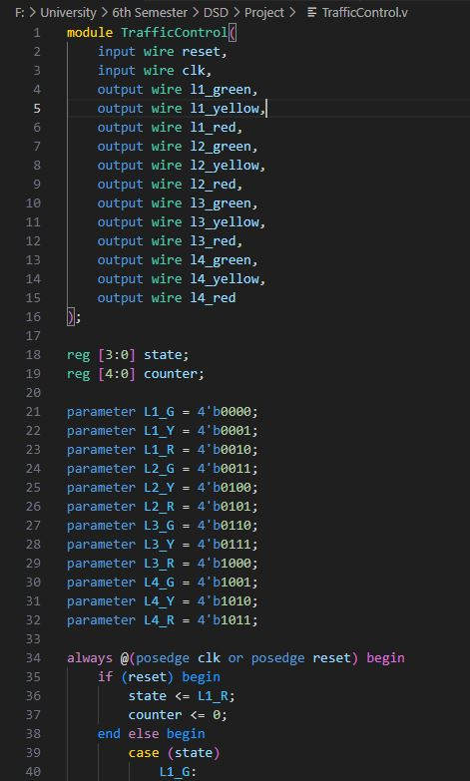

Figure 3 Verilog Code

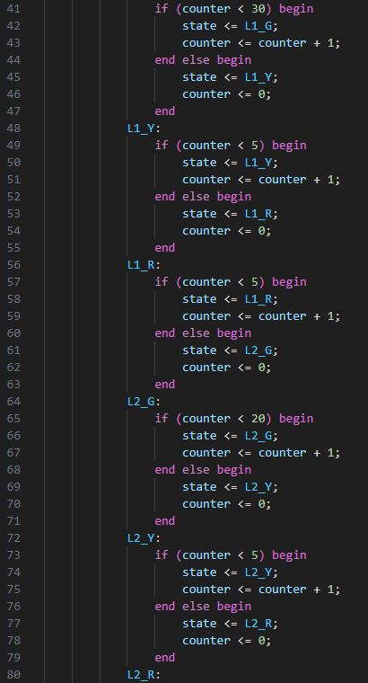

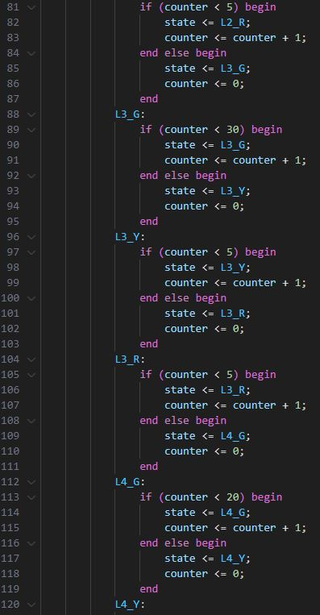

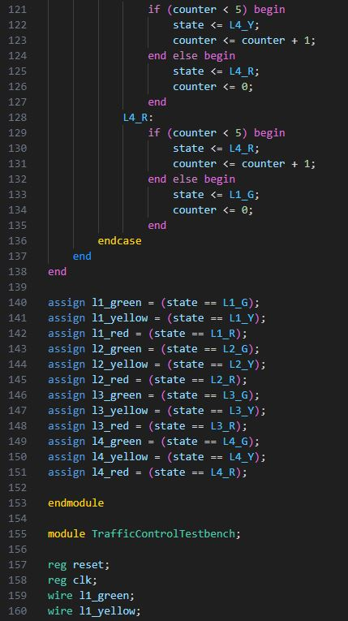

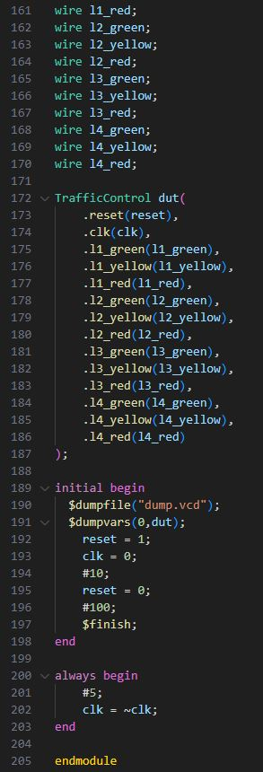

# Flowchart:

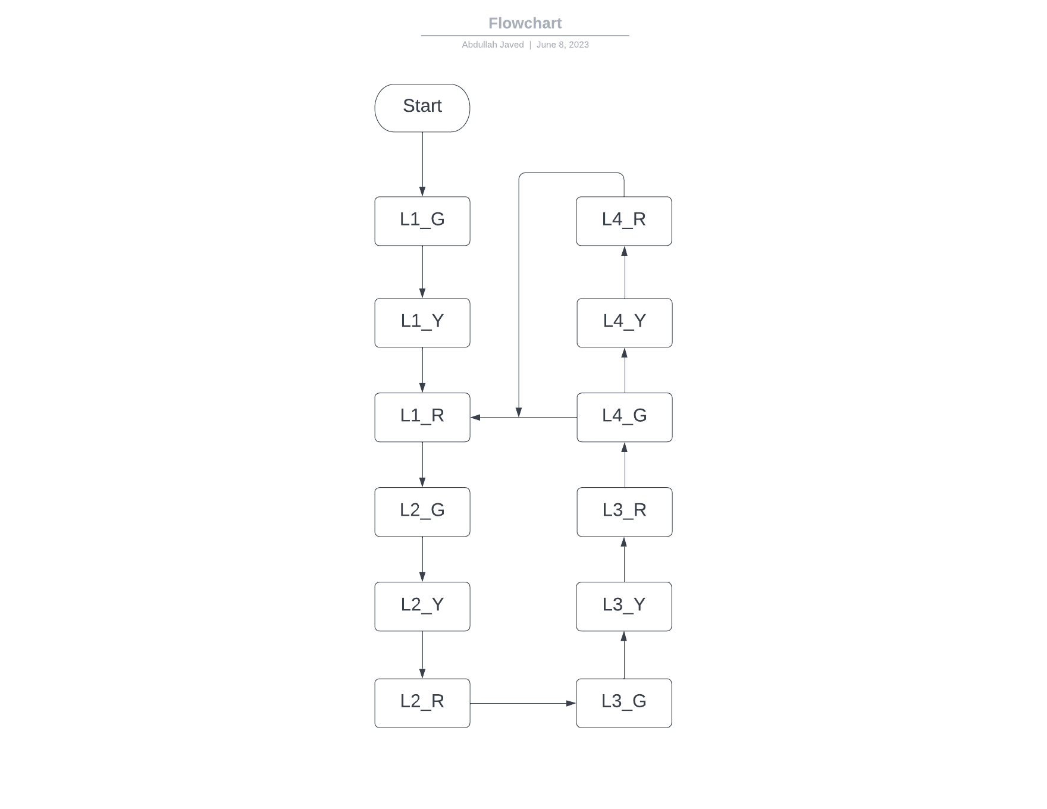

Figure 4 Flowchart

# State Diagram:

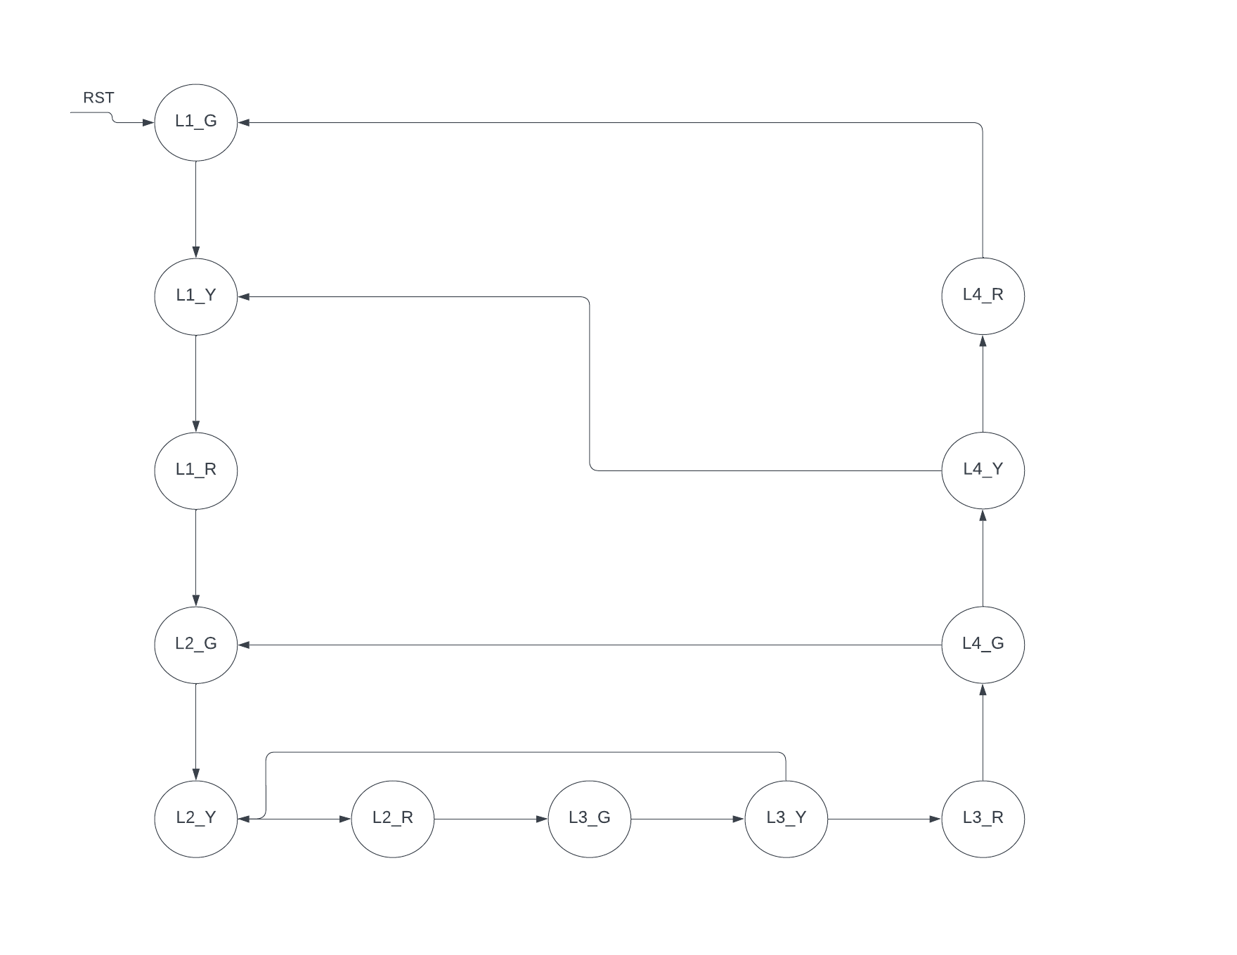

Figure 5 State Diagram

# Conclusion:

The outcome of the proposed system will be a fail-safe and fully functioning Traffic Control System. This system will be automatic, hence it will give movement time to each lane one by one, and will keep on repeating.